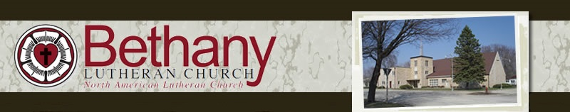
The BANNER November 2019
Dear Disciples,
We all have our special times of church year. Christmas is a high point of the year when we celebrate the birth of Jesus, God's Son. It is a great celebration of God coming to be with us, Emanuel. We love to sing the Christmas Carols that bring us hope and peace in the midst of this chaotic world. Easter Sunday is the grandest of all the celebrations of the Church. We celebrate Jesus Christ's victory over death and the grave. In His resurrection we have the sure and certain hope that we too as God's Children will receive eternal life. Easter and Christmas rank high on my list as they do on many Christian's list. But, pastorally, I must admit the intense preparation for those festivals almost makes them anticlimactic.
There is one Festival that comes around each year rather quietly. But it has a deep significance for the faithful. It is a festival that is mixed with tears and joy and hope. It is a day of remembering and rejoicing. It is the festival of All Saints. In the Lutheran Church we celebrate this festival on the First Sunday of November. This year we celebrate it on November 3rd. We will remember with thanksgiving those saints who have gone to the Church Triumphant since the last All Saints Day. It is a day we rejoice for what Jesus has done for us and for our loved ones in His death and resurrection. This year we will especially remember those whose funerals I was a part of:

Larry Jensen – April 20, 2019, Debra Hedrick – June 4, 2019, James Runneberg – July 20, 2019.
These are special people to their families, to the church family and our community. Most importantly they are special in God's eyes; so special that God would send His only Son to die for them for the forgiveness of their sins, and to raise His Son from the dead to give them the hope of eternal life. That was their hope and their faith in the end and that is what makes them saints. You probably have family members and friends who were special who have died in the Lord this past year or in any year. And they too can be remembered in our hreats on this special day. My aunt Edna Klappenbach died about a month ago in Lewiston, Idaho at the age of 104. She was special to us. As part of the Prayer of the Church we will pray The Litnay of The Saints and during this time you or a family member may come forward and light a candle in their memory. And then in the confident hope of the resurrection we will celebrate Holy Communion where the church on earth is united with all the company of heaven praising God with our unending hymn, "Holy, Holy, Holy, Lord God of power of might...."
Can you see now why I like All Saints Day? A day mixed with tears and joy as we remember what God has done in our loved ones and what is doing with us as continue our faith journey on earth. Come and celebrate and be uplifted by the gospel of our Lord, Jesus Christ.
Joyfully Yours, Pastor David

Request to Provide
Altar Flowers for 2018

If you wish to provide altar flowers for church during 2018, please complete this form. Please place it in the offering plate or mail it to: Bertha Olson, 521 E. Main St. #108, Laurens, IA 50554 Thank you.

Name of person providing flowers: ____

Date desired:

Do you want to provide flowers on this same date from year to year? yes no

Information needed for Sunday bulletin:

Altar Flowers in Loving Memory of:

From:

Or Altar Flowers:
From:

Please contact Bertha Olson, 841-4394, if you have any questions.

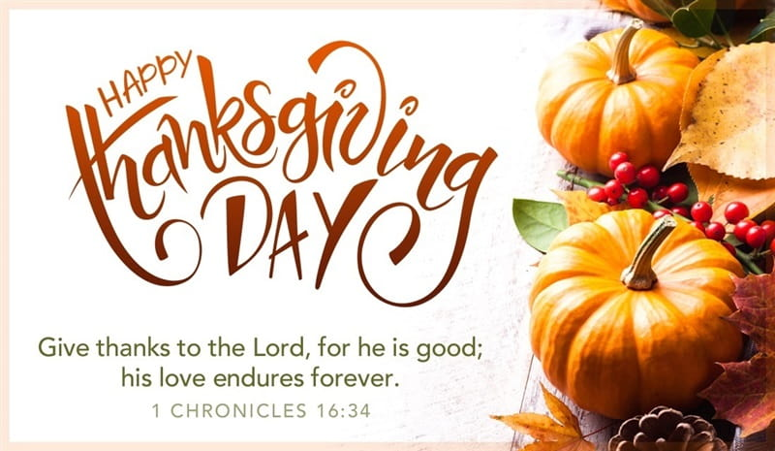
Coffee Fellowship

November 3
1. Jean Swanson (CP)
2. Don & Shirley Kruse
3. Dorothy Sandvig

November 10
1. Linda Galbraith (CP)
2. Denise & Jim Hodgell
3. Elaine & Tom Anderson

November 17
1. Jean Swanson (CP)
2. Tammy Oxenreider
Name | Marriage | November
Armstrong, Dean & Eloise | 11-02
Jamison, Dawn |  | 11-10
Edmonds, Bill |  | 11-16
Nomann, Jim |  | 11-20
Gustafson, Randy |  | 11-26
Roling, Eli |  | 11-29
Caskey, Helen |  | 11-30
3. Gail Olson
November 24
1. Myles & Shirley Pedersen (CP)
2. Jan & Ron Hersom
3. Don & Shirley Kruse

December 1
1. Myles & Shirley Pedersen (CP)
2. Jan & Ron Hersom
3. Pat & Ken Boughey

In case of emergency Pastor David
712-841-2181 (Office)
712-841-2532 Home)
419-603-8350 (Cell)

Birthdays &
Anniversaries

LAURENS COMMUNITY YOUTH GROUP MINUTES OCTOBER 13, 2019
The board members met at the First Christian Church at 5 p.m. Those present were: Pastors: Klappenbach, Frank and Cordell. Angie Christenson, Angie Sobotka, Tammy Swanson, Anne Walstead, Thaine Hopkins and Linda Bieri
The meeting was opened with prayer by Pastor Rita with a time of silence to remember DeWayne Gustafson for his service on our board and to the community youth.
The previous minutes were approved.
The treasurer’s report was given by Thaine. We have $3300 in the treasury. The Haiti trip is a credit given for the 2020 trip. It is now time for each of the three churches to give their $300.
There were 20 kids for the opening kickoff movie and pizza night. Typically, we will expect about a dozen high school and 15 to 20 junior high kids.
Trunk or treat will be Oct 31st from 5 to 6 at the UMC parking lot. Please park by 4:30 and donation of treats will be accepted. If anyone would like to donate, please let us know. It will be held inside if the weather is inclement.
The youth will volunteer to clean up yards in the community, possibly the first Sunday afternoon in November. Adult leaders will be needed.
The youth were asked to write down their faith questions at their first meeting last Sunday. From those questions, the answers will form the curriculum for this year’s study. The pastors will be presenting and interacting with the students to answer their questions throughout this school year during youth group meetings. Each of the three pastors picked from the questions asked for their individual messages. Angie will develop a schedule based on the pastor’s availability and share it with the students, so they can come when their questions will be answered.
Schedule details are as follows: Nov. 24th –Ecumenical Thanksgiving service 7 p.m., so no snacks needed at Methodist Church that night. December 1st: NO YOUTH GROUP. December 8th and 15th will be at Lutheran Church and December 22 will be both high school and junior high Christmas party at Lutheran Church. No Youth Group Dec. 29th.
The Christmas party will be pizza and drink from the church and kids will bring other snacks.
The churches are providing more of a meal this year, thinking about maid rights, hot dogs, tacos, etc. and a drink.
Thaine asked for volunteers from the youth to help for their Nov. 2nd community turkey supper at UMC. Angie has a list of helpers.
Our next meeting will be Dec. 8th at 5 p.m. at Bethany to discuss fund raisers for 2020.

Books for reference in the library:
The books from Lutheran Week, the 2019 annual NALC convocation, will be in the library for your review.
Our theme is Walking by the Spirit with the Fruit of the Spirit.
The smaller book is the NALC statement and study guide using the Bible as the Word of God. It has been developed by the NALC Commission on Theology and Doctrine to be used as a statement of faith and study guide for our NALC congregations. We encourage all to take the time to read it and our congregation to study it together to bring our minds and spirits as one for the discipleship of His kingdom.
The Water Mission book is the international mission for the Women of the NALC.
Please pay particular attention to the Report on Missions page 101 and Report of the Life- toLife Discipleship Team page 147. The Mission Report reports on the Great Commission Society and the Discipleship report says that every congregation needs a discipleship group. These are two worthy causes to include in our goals for 2020.

November 2019
Sunday | Monday | Tuesday | Wednesday | Thursday | Friday | Saturday
 |  | Bethany Lutheran Church  Fellowship/Coffee- 9:30  Adult SS- 9:15  Youth SS- 9:30  Worship-10:30 |  |  | 1 | 2
3  6-8PM Youth Group @FCC | 4  4:00PM Christian Ed Mtg | 5  7:30AM Prayer Meeting  9:30-Coffee  4:00-Worship & Music Mtg | 6 | 7 | 8 | 9
10  6-8PM Youth Group @FCC | 11 | 12  7:30AM Prayer Meeting  9:30-Coffee | 13  7:00PM Council Meeting | 14 | 15 | 16
17  POTLUCK  6-8 Youth  Group @FCC | 18 | 19  7:30AM Prayer Meeting  9:30-Coffee | 20 | 21 | 22 | 23
24  7:00PM Laurens Ecumenical Thanksgiving Service | 22 | 26  7:30AM Prayer Meeting  9:30-Coffee | 27 | 28  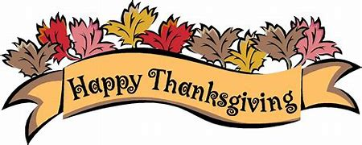 | 29 | 30

